Aim: To obtain the best fit line over single feature scattered datapoints using Linear Regression
IDE: Google Colab

Theory:

Linear regression is a method for determining the best linear relationship between two variables X and Y. If variables X and Y are uncorrelated, it is pointless embarking upon linear regression. However, if a reasonable degree of correlation exists between X and Y then linear regression may be a useful means to describe the relationship between the two variables. The usual approach is to use the least-squares method, which minimizes the squared difference between the actual data points and a straight line. Let [xi,yi], i = 1,2,3,….,N be the N pairs of data values of the variables X and Y. The straight-line relating X and Y is y = mx + c, where m and c are the gradient and constant values (to be determined) defining the straight line. Thus, y(xi) - yi is the difference between the line and data point i (see Fig. 1). Taking all the data points, we seek values of m and c that minimize the squared difference SD.
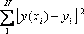

This is achieved by calculating the partial derivatives of SD with respect to m and c and finding the pair [m,c] such that SD is at a minimum.
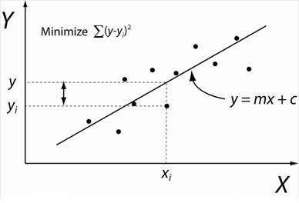

Figure 1: Illustration of Linear Regression. Linear least squares regression, the idea is to find the line y = mx + c that minimizes the mean squared difference between the line and the data points

Batch Gradient Descent:
Gradient Descent is an optimization algorithm used for minimizing the cost function in various machine learning algorithms. It is basically used for updating the parameters of the learning model. Batch gradient descent which processes all the training examples for each iteration of gradient descent. But if the number of training examples is large, then batch gradient descent is computationally very expensive.

Let m be the number of training examples. Let n be the number of features.

Algorithm for batch gradient descent :
Let hθ(x) be the hypothesis for linear regression. Then, the cost function is given by: Let Σ represents the sum of all training examples from i=1 to m.
Jtrain(θ) = (1/2m) Σ( hθ(x^{(i)}) - y^{(i)})²
Repeat {
θj = θj – (learning rate/m) * Σ( hθ(x^{(i)}) - y^{(i)})x ^{(i)}
j
For every j =0 …n
}
Where x ^{(i)} Represents the j^{th} feature of the i^{th} training example. So if m is very large(e.g. 5 million training samples), then it takes hours or even days to converge to the global minimum.That’s why for large datasets, it is not recommended to use batch gradient descent as it slows down the learning.
j

Pre Lab Exercise:
- Explain the meaning of linear regression
Linear regression is used to predict a value by fitting a straight line between input and output data.

- Write three applications of linear regression

Linear regression is used in sales forecasting, house price prediction, and academic performance analysis

- Write three advantages of linear regression

Linear regression is simple, fast, and useful for prediction.

- Write three limitations of linear regression
Linear regression is limited because it assumes linearity, is sensitive to outliers, and cannot model complex relationships.

Methodology:
- Load the basic libraries and packages
- Load the dataset
- Analyse the dataset
- Pre-process the data
- Visualize the Data
- Separate the feature and prediction value columns
- Write the Hypothesis Function
- Write the Cost Function
- Write the Gradient Descent optimization algorithm
- Apply the training over the dataset to minimize the loss
- Find the best fit line to the given dataset
- Observe the cost function vs iterations learning curve

Program (Code):

import numpy as np import pandas as pd
import matplotlib.pyplot as plt

X = np.array([1,2,3,4,5,6,7,8])
Y = np.array([2,4,5,4,5,7,8,9])
m = 0
c = 0

learning_rate = 0.01

iterations = 1000 n = len(X) cost_history = []

for i in range(iterations):
Y_pred = m*X + c
cost = (1/(2*n)) * np.sum((Y_pred - Y)**2) cost_history.append(cost)

dm = (1/n) * np.sum((Y_pred - Y)*X) dc = (1/n) * np.sum(Y_pred - Y)
m = m - learning_rate * dm c = c - learning_rate * dc
print("Final slope (m):", m) print("Final intercept (c):", c) # Scatter plot without line

plt.scatter(X, Y) plt.title("Datapoints Scattering") plt.show()
# Scatter plot with best fit line plt.scatter(X, Y)
plt.plot(X, m*X + c)
plt.title("Best Fit Line") plt.show()
# Cost vs Iterations plt.plot(cost_history) plt.title("Cost vs Iterations") plt.xlabel("Iterations") plt.ylabel("Cost")
plt.show()

Results:
To be attached with
- Datapoints scattering (without best fit line)
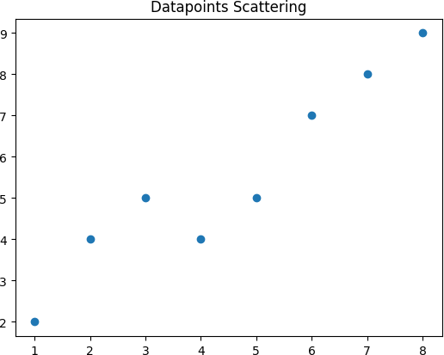

- Scatter plot showing the Best fit line in the last iteration of training3
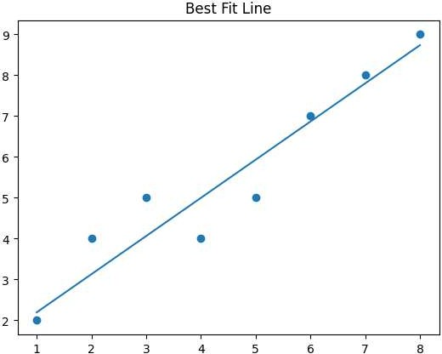
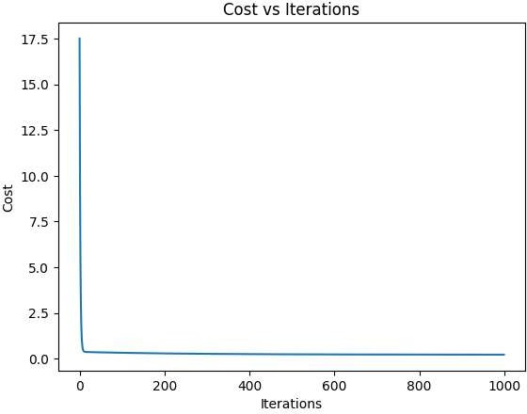

Observation and Result Analysis:
- Nature of the dataset
The nature of a dataset in Artificial Intelligence refers to its type, structure, and characteristics. It includes whether the data is structured or unstructured, labeled or unlabeled, and whether it is balanced or imbalanced. It also considers data quality, size, and types of features (numerical or categorical).

- During Training Process
The training process in Artificial Intelligence is the phase where a model learns from the dataset. The algorithm analyzes input data, finds patterns, and adjusts its parameters (weights) to minimize errors.

- After the training Process
After the training process, the AI model is tested and evaluated using new (unseen) data to check its performance and accuracy. If the results are good, the model is deployed for real-world use.

Post Lab Exercise:

- What are the major assumptions considered in linear regression The main assumptions in linear regression are:
  - Linearity – The relationship between independent and dependent variables is linear.
  - Independence – Observations are independent of each other.
  - Homoscedasticity – Constant variance of errors across all levels of input.
  - Normality – Errors (residuals) are normally distributed.
  - No Multicollinearity – Independent variables are not highly correlated with each other.

- Why MSE is used instead of MAE for calculating the loss function

Mean Squared Error (MSE) is preferred over Mean Absolute Error (MAE) because:
- Differentiability – MSE is smooth and easy to differentiate, which helps in optimization using gradient descent.
- Penalizes Large Errors More – Squaring increases the impact of big errors, improving model

accuracy.
- Mathematical Convenience – Easier to work with in calculations and model training.

- How can the behaviour of outliers be understood while dealing with the unseen dataset

The behaviour of outliers in an unseen dataset can be understood by using techniques like statistical methods (mean, standard deviation, z-score), visualization (box plots, scatter plots), and model evaluation on new data.
Outliers usually cause large prediction errors, so analyzing residuals helps in identifying their impact.

- Derive the Normal Equation for the Linear Regression.
